**Attributes and Keys**

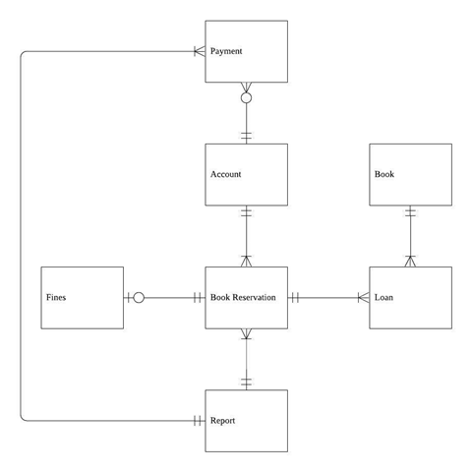

Account (account_no, first_name, last_name, email, password, identity, date_Joined, fine_due)

Book Reservation (reserve_no, reserve_date, account_no*, report_no*)

Loan (reserve_no*, book_id*, collection_date, return_date)

Book (book_id, book_title, language, author, publisher, isbn, publish_year)

Fines (fine_no, day_count, fine_amount, reserve_no*)

Payment (payment_no, amount, payment_method, payment_date, account_no*, report_no*)

Report (report_no, date_created)

**Codes**

**Account Number**

**000001**

**Type of Codes: Sequence Codes**

Six number that shows the number of accounts that had been registered. E.g. 000010 is the 10th account registered, 000021 is the 21st account registered and so on. As our members do not have any special membership, a special method of recording account number is not required. We can also simply find the total number of accounts created by looking at the latest account number.

**Book Reserve Number**

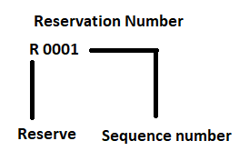

**Type of Codes: Sequence Codes**

The ‘R’ letter is at front of all reservation number to show it is a reservation. A four-number-code is placed after the ‘R’ letter. The four-number-code is the sequence number of the reservation

**Fine Number**

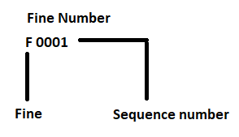

**Type of Codes: Sequence Codes**

The fine number works similarly as the reservation number except it starts with the ‘F’ letter instead of ‘R’.

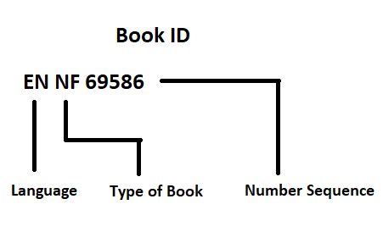 **Book ID**

**Type of Codes: Significant Alphabetic Codes**

|  |  |  |
| --- | --- | --- |
| **Language** | **Type of Book** | **Number Sequence** |
| EN- English  ZH- Chinese  ES- Spanish  FR- French  KO- Korean  JP- Japanese  MS- Malay  TA- Tamil | NF- Non-Fiction  F- Fiction | 5 system generated numbers |

**Payment Number**

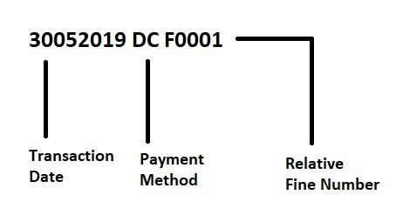

**Type of Codes: Derivation Codes**

|  |  |  |
| --- | --- | --- |
| **Transaction Date** | **Payment Method** | **Relative Fine Number** |
| DDMMYYYY | C- Cash  DC- Debit Card  CC- Credit Card | The fine number which the payment is linked to. |

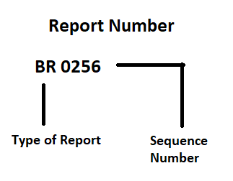**Report Number**

**Type of Codes: Significant Alphabetic Codes**

|  |  |
| --- | --- |
| **Type of Report** | **Sequence Number** |
| BR- Book Report  PR- Payment Report | The number of reports made. There will be 2 report with a same sequence number which is book report and payment report. Reports with same sequence number are made in the same day. |

**Table design**

**Account Table**

|  |  |  |  |
| --- | --- | --- | --- |
| **Field** | **Data Type** | **Remark** | **Format** |
| account_no | varchar(6) | Primary Key | - |
| first_name | varchar(6) | - | - |
| last_name | varchar(20) | - | - |
| email | varchar(30) | - | - |
| password | varchar(16) | - | - |
| identity | varchar (16) | - | - |
| date_Joined | date | - | DD/MM/YYYY |
| fine_due | number (6,2) | - | RM 9,999.99 |

**Book Reservation Table**

|  |  |  |  |
| --- | --- | --- | --- |
| **Field** | **Data Type** | **Remark** | **Format** |
| reserve_no | varchar(5) | Primary Key | - |
| reserve_date | date | - | DD/MM/YYYY |
| book_id | varchar(9) | Foreign Key | Reference Loan Table |
| account_no | varchar(6) | Foreign Key | Reference Account Table |
| report_no | varchar(6) | Foreign Key | Reference Report Table |

**Loan Table**

|  |  |  |  |
| --- | --- | --- | --- |
| **Field** | **Data Type** | **Remark** | **Format or Reference** |
| reserve_no | varchar(5) | Primary Key & Foreign Key | Reference Book Reservation Table |
| book_id | varchar(9) | Primary Key & Foreign Key | Reference Book Table |
| collection_date | date | - | DD/MM/YYYY |
| return_date | date | - | DD/MM/YYYY |

**Book Table**

|  |  |  |  |
| --- | --- | --- | --- |
| **Field** | **Data Type** | **Remark** | **Format or Reference** |
| book_id | varchar(9) | Primary Key | - |
| book_title | varchar (50) | - | - |
| language | varchar (20) | - | - |
| author | varchar (50) | - | - |
| publisher | varchar (50) | - | - |
| isbn | varchar (13) | - | - |
| publish_year | number (4) | - | - |

**Fines Table**

|  |  |  |  |
| --- | --- | --- | --- |
| **Field** | **Data Type** | **Remark** | **Format or Reference** |
| fine_no | varchar(5) | Primary Key | - |
| day_count | number (6) | - | - |
| fine_amount | number (6,2) | - | RM 999,999.99 |
| payment_status | char(1) | - |  |
| account_no | varchar(6) | Foreign Key | Reference Account Table |

**Payment Table**

|  |  |  |  |
| --- | --- | --- | --- |
| **Field** | **Data Type** | **Remark** | **Format or Reference** |
| payment_no | varchar(5) | Primary Key | - |
| amount | number (6,2) | - | RM 999,999.99 |
| payment_method | char(2) | - | - |
| payment_date | date | - | DD/MM/YYYY |
| report_no | varchar(6) | Foreign Key | Reference Report Table |
| account_no | varchar(6) | Foreign Key | Reference Account Table |

**Report Table**

|  |  |  |  |
| --- | --- | --- | --- |
| **Field** | **Data Type** | **Remark** | **Format or Reference** |
| report_no | varchar(6) | Primary Key | - |
| date_created | date | - | DD/MM/YYYY |

**Data Records**

**Account**

|  |  |  |  |  |  |  |  |
| --- | --- | --- | --- | --- | --- | --- | --- |
| account_no | first_name | last_name | email | password | identity | date_Joined | fine_due |
| 000001 | Somerset | Leeson | [sleeson0@cargocollective.com](mailto:sleeson0@cargocollective.com) | 48CurL | 271102-79-9932 | 18-FEB-18 | $0.00 |
| 000002 | Emmott | Jobb | ejobb1@discovery.com | jO4sZZxha5U | 700223-25-1841 | 11-MAR-18 | $0.00 |
| 000003 | Loise | Poor | lpoor2@histats.com | GzjxDrECFru | 340724-21-8936 | 10-APR-18 | $0.00 |
| 000004 | Sal | Soigoux | ssoigoux3@alibaba.com | lre3e7Eoqvb | 221123-41-9313 | 10-APR-18 | $2.00 |
| 000005 | Zorah | Surphliss | zsurphliss4@pinterest.com | ZLjsE1 | 459066860 | 06-MAY-18 | $3.00 |
| 000006 | Ashli | Chown | achown5@123-reg.co.uk | yZMnw805 | 501006-30-9106 | 22-MAY-18 | $0.00 |
| 000007 | Ernest | Bru | ebru6@imdb.com | FKzMp9VGQ | 617392043 | 05-JUN-18 | $8.00 |
| 000008 | Nat | Fuge | nfuge7@blinklist.com | WLC8eV | 380224-05-0546 | 07-JUL-18 | $0.00 |
| 000009 | Andre | Masters | amasters0@1und1.de | cBJ6ov | 800190-10-1234 | 08-JUL-18 | $0.00 |
| 000010 | Tori | Krout | tkrouut1@trellian.com | sd9tKmGt | 811190-05-1546 | 09-JUL-18 | $0.00 |

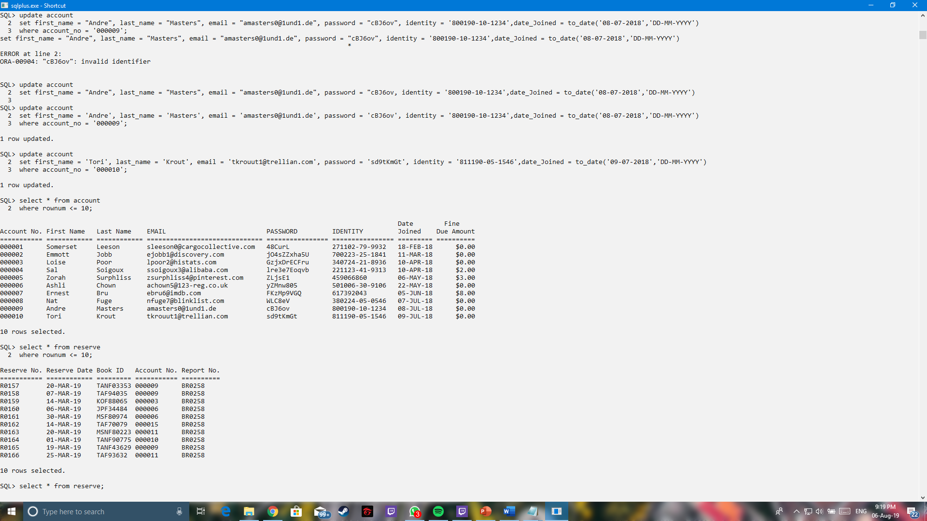SQL result for Account Table

**Book Reservation**

|  |  |  |  |  |
| --- | --- | --- | --- | --- |
| reserve_no | reserve_date | book_id | account_no | report_no |
| R0157 | 20-MAR-19 | TANF03353 | 000009 | BR0258 |
| R0158 | 07-MAR-19 | TAF94035 | 000009 | BR0258 |
| R0159 | 14-MAR-19 | KOF88065 | 000003 | BR0258 |
| R0160 | 06-MAR-19 | JPF34484 | 000006 | BR0258 |
| R0161 | 30-MAR-19 | MSF80974 | 000006 | BR0258 |
| R0162 | 14-MAR-19 | TAF70079 | 000015 | BR0258 |
| R0163 | 20-MAR-19 | MSNF80223 | 000011 | BR0258 |
| R0164 | 01-MAR-19 | TANF90775 | 000010 | BR0258 |
| R0165 | 19-MAR-19 | TANF43629 | 000009 | BR0258 |
| R0166 | 25-MAR-19 | TAF93632 | 000011 | BR0258 |

SQL result from Reserve Table

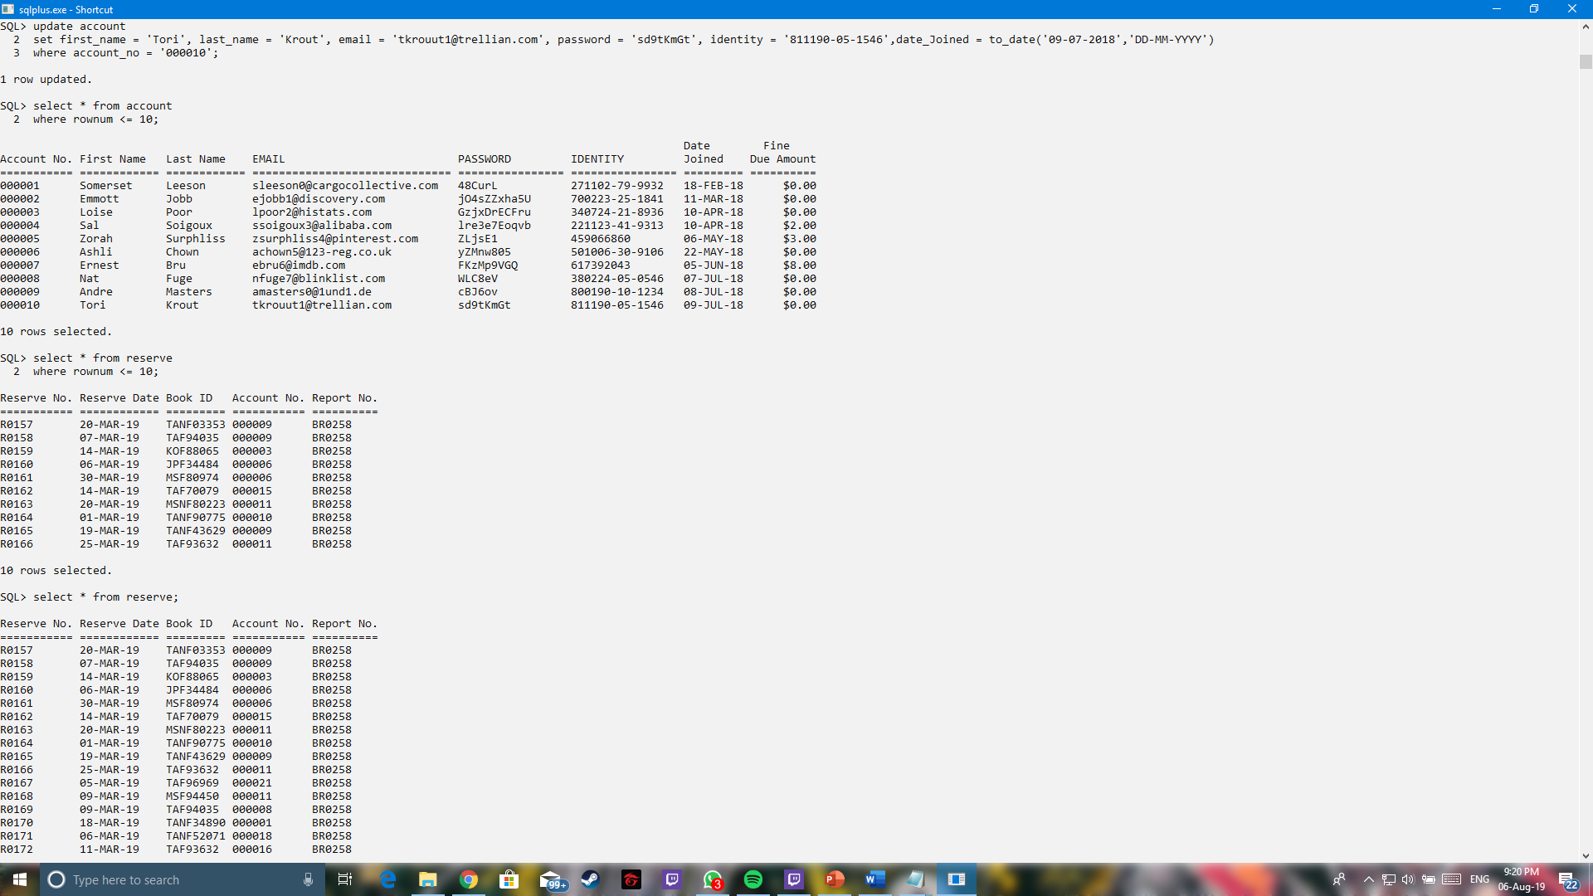

**Loan**

|  |  |  |  |
| --- | --- | --- | --- |
| reserve_no | book_id | collection_date | return_date |
| R0184 | TANF1014 | 10-MAY-19 | 10-JUN-19 |
| R0185 | TANF51506 | 18-MAY-19 | 18-JUN-19 |
| R0186 | TANF92983 | 06-MAY-19 | 06-JUN-19 |
| R0187 | TAF57315 | 17-MAY-19 | 17-JUN-19 |
| R0188 | JPF80350 | 04-MAY-19 | 04-JUN-19 |
| R0189 | MSF81988 | 24-MAY-19 | 24-JUN-19 |
| R0190 | ESNF28767 | 27-MAY-19 | 27-JUN-19 |
| R0191 | TAF96337 | 27-MAY-19 | 27-JUN-19 |
| R0192 | JPF06092 | 09-MAY-19 | 09-JUN-19 |
| R0193 | MSNF51633 | 22-MAY-19 | 22-JUN-19 |

SQL result from Loan Table

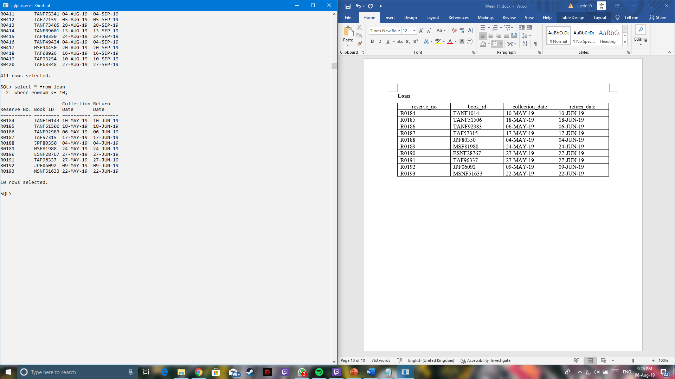

**Book Table**

|  |  |  |  |  |  |  |
| --- | --- | --- | --- | --- | --- | --- |
| book_id | book_title | language | author | publisher | isbn | publish_year |
| TANF85362 | Advanced Natural Gas Engineering | Tamil | Ciro Tomaselli | Gulf Publishing Company | 9781933762388 | 2010 |
| KOF81137 | Coding and Decoding: Seismic Data | Korean | Jonas Detheridge | Pargamon | 9780080451596 | 2010 |
| JPNF24921 | The Dusky Dolphin | Japanese | Salem Monkhouse | Academic Press | 9780123737236 | 2010 |
| MSF72329 | Beer in Health and Disease Prevention | Malay | Minor Suttling | Academic Press | 9780123738912 | 2008 |
| TANF26309 | Genetically Modified Plants | Tamil | Devlen Talton | Academic Press | 9780123741066 | 2009 |

SQL result from Book Table

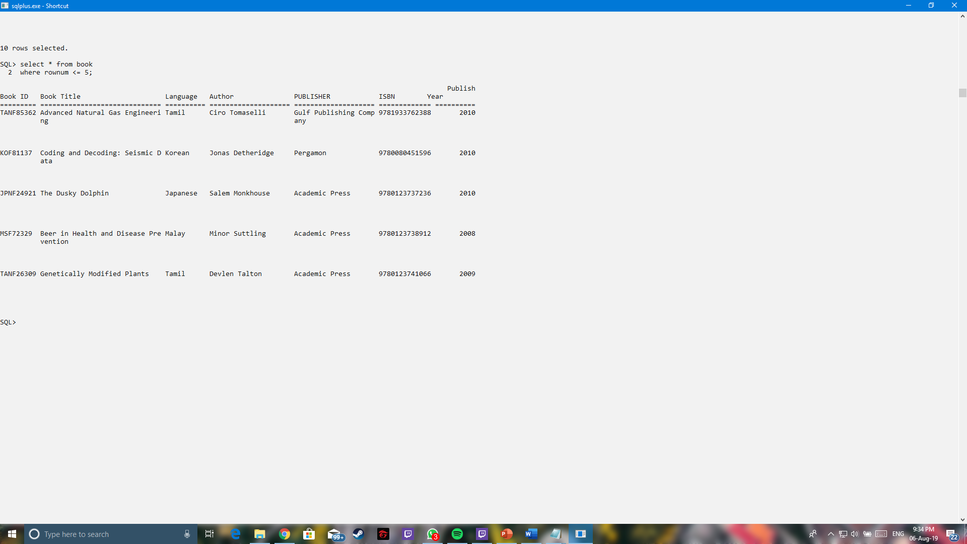

**Fine Table**

|  |  |  |  |  |
| --- | --- | --- | --- | --- |
| fine_no | day_count | fine_amount | reserve_no | payment_status |
| F00001 | 1 | $1.00 | R0017 | n |
| F00002 | 1 | $1.00 | R0027 | n |
| F00003 | 4 | $4.00 | R0025 | p |
| F00004 | 3 | $3.00 | R0028 | p |
| F00005 | 4 | $4.00 | R0102 | p |

SQL result from Fine Table

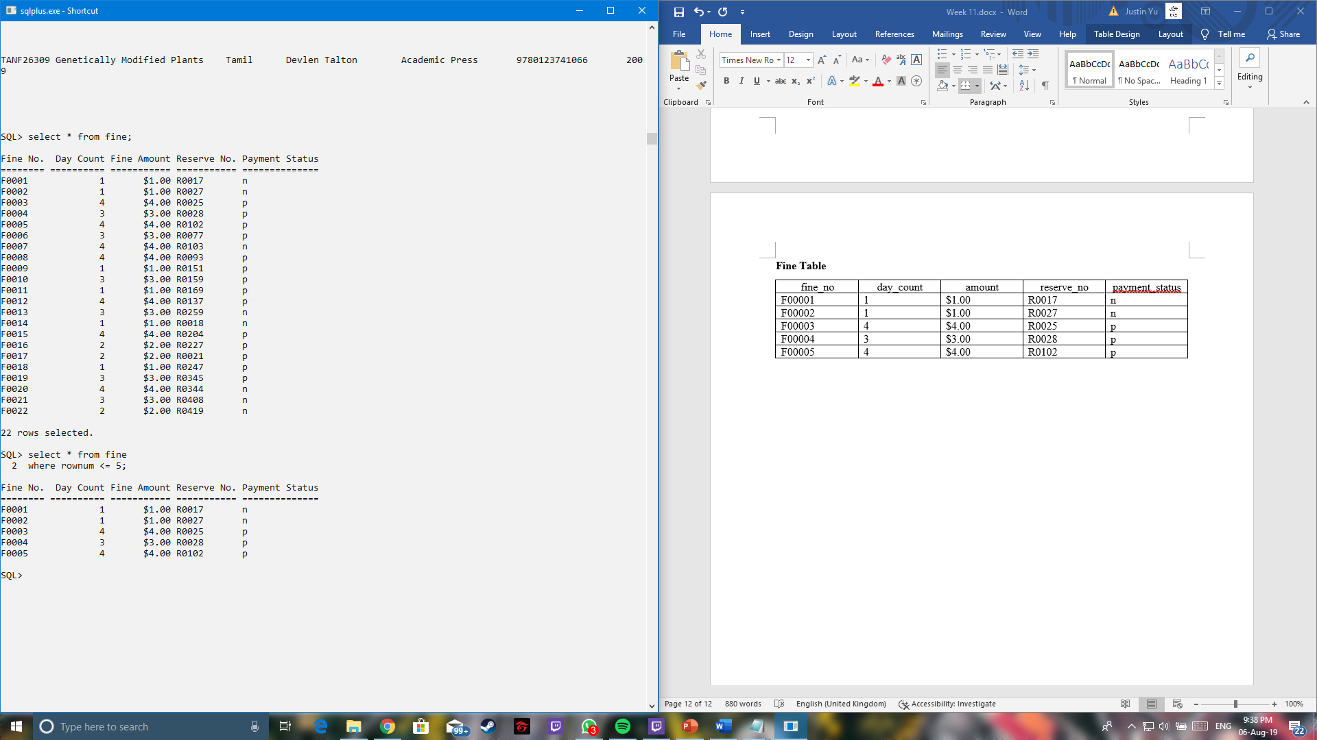

**Payment Table**

|  |  |  |  |  |  |
| --- | --- | --- | --- | --- | --- |
| payment_no | amount | account_no | report_no | payment_method | payment_date |
| 03032019CCF0003 | $4.00 | 000014 | PR0256 | CC | 03-MAR-19 |
| 26032019DCF0004 | $3.00 | 000015 | PR0256 | DC | 26-MAR-19 |
| 20042019DCF0008 | $4.00 | 000009 | PR0258 | DC | 20-APR-19 |
| 26042019CCF0009 | $1.00 | 000003 | PR0259 | CC | 26-APR-19 |
| 26042019CCF0010 | $3.00 | 000003 | PR0259 | CC | 26-APR-19 |

SQL result from Payment Table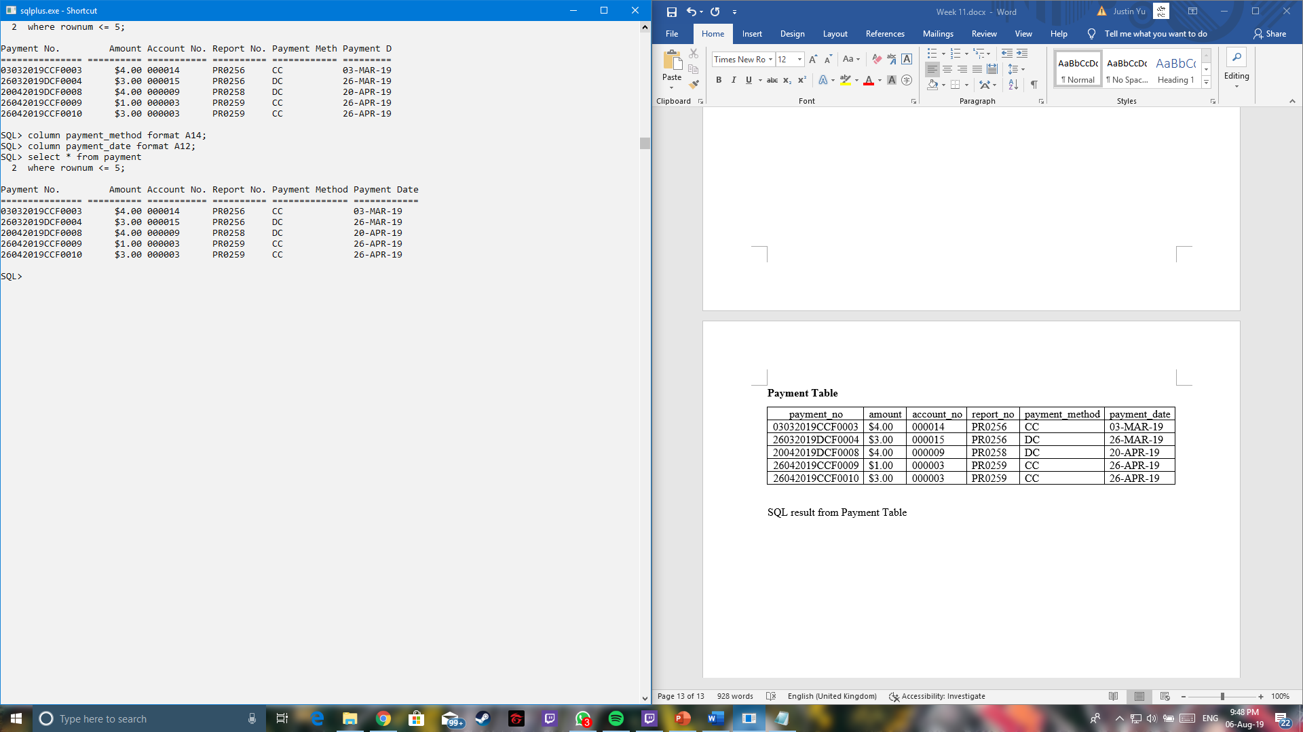

**Report Table**

|  |  |
| --- | --- |
| report_no | date_created |
| BR0256 | 31-JAN-19 |
| PR0256 | 31-JAN-19 |
| BR0257 | 28-FEB-19 |
| PR0257 | 28-FEB-19 |
| BR0258 | 31-MAR-19 |

SQL result from Report Table

